 | Institute of Information Technology  Quaid-i-Azam University Islamabad.

Software Requirement Specification
(SRS DOCUMENT)

for
Project Title
Version 1.0
By
Student Name 1 --------------------------------
Student Name 2 --------------------------------
Student Name 3 --------------------------------

Supervisor
Supervisor Name

Co-Supervisor (if any)
Co-Supervisor Name

Bachelor of Science in Information Technology (20xx-20xx)

Revision History
Name | Date | Reason for Changes | Version

Application Evaluation History
Comments (by committee)  *include the ones given at scope time both in doc and presentation | Action Taken

Supervised by
Supervisor’s Name
Signature______________

Table of Contents

1. Introduction 1
1.1 Purpose 1
1.2 Scope 1
1.3 Modules 1
1.4 Overview 1
2. Overall Description 1
2.1 Product Perspective 1
2.2 User classes and characteristics 1
2.3 Operating Environment 1
2.4 Design and Implementation Constraints 2
3. Requirement Identifying Technique 2
4. Functional Requirements 2
4.1 Functional Requirement X 3
5. Non-Functional Requirements 3
5.1 Reliability 3
5.2 Usability 4
5.3 Performance 4
5.4 Security 4
6. External Interface Requirements 4
6.1 User Interfaces Requirements 4
6.2 Software interfaces 5
6.3 Hardware interfaces 5
6.4 Communications interfaces 5
7. References 5

Introduction
The introduction of the Software Requirements Specification (SRS) provides a complete overview of the Printsy system. It outlines the purpose, scope, system modules, and overall structure of the document. This SRS serves as a formal basis for understanding, developing, testing, and validating the Printsy printing and delivery platform

Purpose
The purpose of this SRS is to specify the requirements for Printsy, an online document printing and delivery system. This SRS is intended for software developers, project managers, QA testers, UI/UX designers, and system administrators involved in the design, development, and deployment of Printsy

Scope
Printsy is a web-based platform that allows users to upload documents, customize their print settings, pay online, and receive printed material at their doorstep.
The purpose of Printsy is to automate and simplify the printing process, remove the need for physical visits to print shops, and provide shop owners with a digital order management system.
- High-Level Features Include:
- Document upload (PDF, DOCX, PPT, JPG, PNG)
- Print customization (paper size, orientation, color mode, binding)
- Secure online payments (Stripe, EasyPaisa, JazzCash)
- Order tracking with real-time delivery status
- Notification system (email/SMS)
- File conversion module (DOCX → PDF, JPG → PDF)
- User order history with auto-deletion after a retention period
- Shop owner dashboard for managing print jobs
- End-to-end encryption for secure data handling
.

Modules
The major modules of the Printsy system include:
- M1 — User Authentication Module
Handles user registration, login, password recovery, and role-based access.
- M2 — Document Upload Module
Allows users to upload supported file formats securely.
- M3 — Print Customization Module
Provides options for page size, orientation, color settings, paper type, binding, and number of copies.
- M4 — Order & Payment Module
Manages order creation, pricing calculation, payments, and invoice generation.
- M5 — Delivery Module
Handles address input, rider assignment, delivery tracking, and delivery updates.
- M6 — Admin/Shop Dashboard Module
Enables shop owners to view pending orders, process prints, update statuses, and review analytics.
- M7 — Notification Module
Sends confirmation emails/SMS and status updates to users.
- M8 — User History Module
Displays past orders and allows reorder functionality.
- M9 — Auto-Deletion Module
Automatically removes order history after a defined retention period.
- M10 — Page Size Details Module
Shows detailed information and visual previews for available paper sizes.
- M11 — File Conversion Module
Converts DOCX, PPT, and images to PDF for compatibility.
- M12 — Security Module
Implements encryption, secure APIs, and protected data transmission.
Each module has a unique label to allow traceability across system elements.
.

Overview
The remainder of this SRS is organized as follows:
- Section 2: Overall system description, user classes, constraints, and environment
- Section 3: Requirement identification techniques used
- Section 4: Detailed functional requirements (FRs) of all modules
- Section 5: Non-functional requirements (performance, reliability, security, usability)
- Section 6: External interface requirements (UI, hardware, software, communications)
- Section 7: References
- Appendix A: Diagrams (Use Case Diagram, Context Diagram, User Class Table

Overall Description
This section presents a high-level overview of the product and the environment in which it will be used, the anticipated users, and known constraints, assumptions, and dependencies.

Product Perspective
Printsy is an entirely new web-based system designed to automate online document printing.
It is not an extension of an existing application; rather, it is an independent platform that integrates:
- Online payment gateways
- File format converters
- Email/SMS notification services
- Delivery partner APIs
- Shop owner dashboard interfaces
Printsy acts as the central system between:
- Users uploading files →
- Print shops processing orders →
- Delivery services executing deliveries
A context diagram (in Appendix A) illustrates Printsy’s interactions with external systems such as payment gateways and SMS APIs
.

User classes and characteristics
User Class | Description
End User / Customer | Uploads documents, customizes print settings, pays online, and tracks delivery. Basic computer literacy required.
Shop Owner | Receives print jobs, processes orders, updates order status. Requires familiarity with business operations but minimal technical knowledge.
Admin | Manages system configuration, oversees shop activity, resolves disputes, and monitors logs. Must have technical and supervisory expertise.
Delivery Rider (optional external role) | Reads and updates delivery status via mobile interface.

Operating Environment
Printsy will operate in the following environment:
- Client-Side (User Environment)
- Modern web browsers:
  - Google Chrome
  - Microsoft Edge
  - Safari
- Server-Side Environment
- Web Server: Linux (Ubuntu) / Windows Server
- Backend Framework: Node.js / Express.js
- Frontend: React.js
- Database: MySQL / MongoDB
- Cloud/Hosting: AWS / Azure
- Deployment Environment
- Online, accessible globally
- Data centers located according to hosting provider
- Mobile-responsive interface for smartphones
OE-1: The system shall operate correctly in all major mobile and desktop browsers.
OE-2: The server shall support at least 500 concurrent requests.

.

Design and Implementation Constraints
The following constraints apply to the Printsy system:
CON-1: The system must use online payment APIs such as Stripe, EasyPaisa, and JazzCash.
CON-2: The system must support secure encryption (HTTPS, SSL/TLS).
CON-3: Only supported file formats (PDF, DOCX, PPT, JPG, PNG) may be uploaded.
CON-4: Document preview must be generated using open-source or licensed libraries.
CON-5: Payment gateway use may require compliance with regional regulations.
CON-6: Auto-deletion policies must comply with data privacy standards.
CON-7: File conversion accuracy may depend on third-party libraries

Requirement Identifying Technique
To accurately define the system requirements of Printsy, a combination of requirement identification techniques was used. Each technique contributed to understanding different aspects of user interaction, system behavior, and backend processing.
- 3.1 Use Case Modeling
Use case diagrams and detailed use case descriptions were used because Printsy is an interactive end-userapplication.
This technique helps identify:
- User actions (upload file, customize print, make payment)
- System responses (validate file, calculate price, update order status)
- Key actors (User, Shop Owner, Admin)
It ensures that all functional requirements support real usage scenarios.
- 3.2 Event–Response Table
Certain parts of Printsy operate automatically in the background — for example:
- Auto-deletion of order history
- Payment confirmation processing
- Delivery notifications
Event–response tables help describe how the system reacts to backend events like “payment received,” “order completed,” or “file conversion failed.”
- 3.3 Storyboarding
Storyboarding was used to model graphically intensive modules, such as:
- File upload interface
- Print customization UI
- Dashboard screens
.

Examples of above techniques are given in Appendix A

Functional Requirements
This section describes the complete functional behavior of Printsy.
Requirements are written in natural language, each with a unique identifier (FR-X), and divided by feature/module..

Functional Requirement X
Itemize the specific functional requirements associated with each feature. These are the software capabilities that must be implemented for the user to carry out the feature’s services or to perform a use case. Describe how the product should respond to anticipated error conditions and to invalid inputs and actions. Uniquely label each functional requirement, as described earlier. You can create multiple attributes for each functional requirement, such as rationale, source, dependencies, etc. The following template is required to write functional requirements. For further detail see Chapter 11” Writing excellent requirements”.

Table 1: FR-1 — User Registration
Identifier | FR-1
Title | User Registration
Requirement | The User shall be able to register by providing name, email, password, and phone number. The system shall validate all required fields before creating the account.
Source | Stakeholder meeting, user needs
Rationale | Users must have authenticated access to upload files and place orders.
Business Rule (if required) | Email must be unique. Password must meet security policy
Dependencies | None
Priority | High

Table 1: FR-2 — User Login

Identifier | FR-2
Title | User Login
Requirement | The User shall be able to log in using email and password. The system shall verify credentials and grant role-based access.
Source | User workflow
Rationale | Only authenticated users can create orders or access dashboards
Dependencies | FR-1
Priority | High

Table 1: FR-3 — Place order
Identifier | FR-3
Title | Place Order
Requirement | The system shall allow the user to place a print order by uploading a document, previewing the uploaded file, viewing detailed page size information, selecting print customization options including paper size, color mode, orientation, binding type, and number of copies, and confirming the order details before submission.
Source | User requirements, stakeholder meeting
Rationale | Placing a print order is the core functionality of the system and allows users to submit documents with accurate print specifications.
Business Rule (if required) | Only supported file formats (PDF, DOCX, PPT, JPG, PNG) shall be accepted. The user must upload a file, preview it, and select a valid page size and required customization options before placing an order.
Dependencies | FR-2 (User Login), FR-9 (file conversion), FR-16(Secure File Storage)
Priority | High

Table 1: FR-4 — Price Calculation

Identifier | FR-4
Title | Price Calculation
Requirement | The system shall automatically calculate total cost based on customization settings and number of pages.
Source | Shop owner and admin input
Rationale | Users must know total cost before ordering
Business Rule (if required) | Shops may set their own price per page.
Dependencies | FR-3 Place order
Priority | High

Table 1: FR-5 — Payment Processing

Identifier | FR-5
Title | Online Payment
Requirement | The system shall allow users to pay using Stripe, EasyPaisa, or JazzCash. The system shall validate payment success before order confirmation.
Source | Scope document
Rationale | Required for online-only workflow
Dependencies | FR-4 Price calculation
Priority | High

Table 1: FR-6 — Order Creation

Identifier | FR-6
Title | Create Order
Requirement | On successful payment, the system will generate an order ID, save order details, and notify the print shop.
Source | End-to-end workflow
Rationale | Core operation of Printsy.
Dependencies | FR-5
Priority | High

Table 1: FR-7 — Track Order Status

Identifier | FR-7
Title | Order Tracking
Requirement | The User shall be able to track order status (Pending → Printing → Out for Delivery → Delivered).
Source | Customer requirement
Rationale | Provides transparency in delivery workflow.
Dependencies | FR-6
Priority | Medium

Table 1: FR-8 — Delivery Management
Identifier | FR-8
Title | Delivery Assignment
Requirement | The system should allow the print shop or admin to assign a delivery rider and update the delivery status.
Source | Delivery process requirement
Rationale | Required for physical delivery workflow.
Dependencies | FR-7
Priority | Medium

Table 1: FR-9 — File Conversion Module

Identifier | FR-9
Title | File Conversion
Requirement | The system shall convert DOCX, PPT, JPG, and PNG files into PDF for compatibility before printing.
Source | Module list
Rationale | Printing requires unified PDF format.
Dependencies | FR-3 (Place Order)
Priority | High

Table 1: FR-10 — Shop Owner Dashboard

Identifier | FR-10
Title | Shop Dashboard
Requirement | The Shop Owner shall be able to view incoming orders, update status, set prices, and view reports.
Source | Shop workflow
Rationale | Needed for business operations
Dependencies | FR-6(Order Creation)
Priority | High

Table 1: FR-11 — Admin Dashboard

Identifier | FR-11
Title | Admin Panel
Requirement | The admin shall be able to manage shops, users, delivery settings, and system policies.
Source | Supervisor requirement
Rationale | Admin must control system-wide operations
Dependencies | FR-10(Shop Owner Dashboard)
Priority | High

Table 1: FR-12 — Notification System
Identifier | FR-12
Title | Notifications
Requirement | The system shall send SMS/Email notifications for order confirmation, payment status, and delivery updates.
Source | Scope
Rationale | Keeps users informed at each step.
Dependencies | FR-6 (Order Creation), FR-7(Track Order Status)
Priority | Medium

Table 1: FR-13 — User Order History

Identifier | FR-13
Title | Order History
Requirement | Users shall be able to view past orders, including file name, price, date, and status.
Source | Customer need
Rationale | Users often reorder the same documents
Dependencies | FR-6
Priority | Medium

Table 1: FR-14 — Reorder Function
Identifier | FR-14
Title | Reorder
Requirement | Users shall be able to reorder a previously printed document with a single click
Source | User requirement
Rationale | Saves time for frequently printed documents
Dependencies | FR-13
Priority | Medium

Table 1: FR-15 — Auto-Deletion of Order History

Identifier | FR-15
Title | Auto-Deletion
Requirement | The system shall automatically delete order history after the retention period (e.g., 30 days)
Source | Privacy requirement
Rationale | Protect user privacy and reduce storage load
Dependencies | FR-13
Priority | Medium

Table 1: FR-16 — Secure File Storage

Identifier | FR-16
Title | Secure Document Storage
Requirement | The system should encrypt stored user documents and restrict access to authorized roles only.
Source | Security module
Rationale | Protect confidential documents
Dependencies | FR-3
Priority | High

Table 1: FR-17 — Cancel Order
Identifier | FR-17
Title | Cancel Order
Requirement | The system shall allow users to cancel a print order before it reaches the printing stage.  .
Source | User requirements
Rationale | Users may need to cancel orders due to mistakes or changes in requirements.
Business Rule (if required) | Orders cannot be canceled once printing has started. Refund policy applies if payment is completed.
Dependencies | FR-6 (Order Placement), FR-5 (Online Payment)
Priority | Medium

Table 1: FR-18 — Comment and Review
Identifier | FR-18
Title | Comment and review
Requirement | The system shall allow users to submit comments and ratings for completed print orders  .
Source | Stakeholder feedback
Rationale | User feedback helps improve service quality and trust.
Business Rule (if required) | Reviews can only be submitted after order delivery.
Dependencies | FR-8 (Order Tracking), FR-10 (Order History)
Priority | Medium

Table 1: FR-19 — Review Overview
Identifier | FR-19
Title | Review Overview
Requirement | The system shall display an overview of user comments and ratings to shop owners and admins.  .
Source | Business requirements
Rationale | Enables monitoring of service quality and customer satisfaction.
Business Rule (if required) | Only shop owners and admins can review analytics.
Dependencies | FR-18 (Comment and Review)
Priority | Medium

Table 1: FR-20 — Sales Report Generation
Identifier | FR-20
Title | Sales Report Generation
Requirement | The system shall generate sales reports showing total orders, revenue, and transaction history  .
Source | Business management requirements
Rationale | Helps shop owners and admins track business performance.
Business Rule (if required) | Reports can be generated daily, weekly, or monthly
Dependencies | FR-6 (Order Placement), FR-7 (Online Payment)
Priority | High

Table 1: FR-21 — Change Order
Identifier | FR-21
Title | Change Print Order
Requirement | The system shall allow users to modify an existing print order by changing the uploaded file, page size, or print customization options before the order enters the printing stage.  .
Source | User requirements
Rationale | Users may need to correct mistakes or update print preferences after placing an order.
Business Rule (if required) | Order modifications are not allowed once the printing process has started. Updated order details may recalculate the total cost.
Dependencies | FR-3 (Place Order), FR-5 (Payment)
Priority | Medium

Table 1: FR-22 — Confirm Delivery
Identifier | FR-22
Title | Confirm Order Delivery
Requirement | The system shall allow users to confirm successful delivery of their print order after receiving it at the specified address.  .
Source | Stakeholder requirements
Rationale | Confirms order completion and enables post-delivery actions such as reviews and order closure.
Business Rule (if required) | Delivery confirmation can only be submitted after the order status is marked as “Delivered.”  .
Dependencies | FR-8 (Order Tracking), FR-10 (User Order History), FR-15 (Comment and Review)
Priority | Medium

Table 1: FR-23 — Logout System
Identifier | FR-23
Title | Logout
Requirement | The system shall allow users to log out securely and invalidate session tokens.
Source | Standard requirement
Rationale | Protects account from unauthorized access.
Dependencies | FR-2
Priority | Medium

Non-Functional Requirements
This section describes the quality attributes that the Printsy system must meet beyond basic functionality. These include reliability, usability, performance, and security requirements. Each requirement is specific, measurable, and verifiable.

Reliability
Reliability ensures that the system remains operational without failure during normal operation.
REL-1: The system shall maintain a minimum uptime of 99% during operational hours, excluding scheduledmaintenance.
REL-2: The system shall achieve a Mean Time Between Failures (MTBF) of at least 500 hours.
REL-3: The system shall automatically detect and log application errors, file processing failures, and payment gateway failures.
REL-4: In case of file upload failure, the system shall notify the user and allow immediate retry without data loss.
REL-5: The system shall maintain data integrity during server restarts, network issues, or power interruptions.
REL-6: If a payment gateway request fails or times out, the system shall roll back the transaction and prevent duplicate charging.
REL-7: The system shall ensure that auto-deletion tasks run consistently without user intervention.

Usability
Usability ensures that Printsy is easy to learn, simple to use, and accessible.
USE-1: The system shall allow a new user to successfully register and place an order within 5 minutes without external help.
USE-2: The interface shall remain consistent across all screens, including buttons, fonts, and navigation elements.
USE-3: The system shall display clear error messages for invalid file formats, failed uploads, and payment issues.
USE-4: The system shall support mobile-responsive design to allow order submission via smartphones and tablets.
USE-5: The system shall provide tooltips and help text for print customization options (e.g., paper size, orientation).
USE-6: The system shall allow users to reorder a previous print job with one click.
USE-7: The interface shall be accessible for users with visual impairments using high-contrast UI and readable fonts.

Performance
Performance requirements define system speed, throughput, scalability, and responsiveness.
PER-1: 95% of pages/screens in the system shall load within 3 seconds over a 20 Mbps connection.
PER-2: File uploads of up to 25 MB shall complete within 10 seconds under normal network conditions.
PER-3: The system shall support at least 300 concurrent users without performance degradation.
PER-4: Payment processing shall complete within 5 seconds, excluding third-party delays.
PER-5: Order status updates shall propagate to users within 2 seconds after the shop owner updates them.
PER-6: The system shall handle file conversion (DOCX/PPT → PDF) in under 8 seconds for files under10MB.
PER-7: The database shall respond to 95% of queries in under 200 milliseconds.

Security
Security requirements protect user data, documents, payments, and system access.
SEC-1: Only authenticated users shall access their own files, orders, or personal information.
SEC-2: The system shall restrict admin, shop owner, and user roles using role-based access control (RBAC).
SEC-3: Sensitive data such as passwords, payment tokens, and addresses shall never be stored in plain text.
SEC-4: The system shall ensure that uploaded documents cannot be accessed without authorization.
SEC-5: The system shall automatically log suspicious activities such as multiple failed logins.
SEC-6: All communication between client and server shall use secure transmission protocols.
SEC-7: The system shall enforce session timeouts after 15 minutes of inactivity.
SEC-8: The auto-deletion module shall ensure permanently removing user files after the retention period to protect privacy.
SEC-9: The system shall validate all file uploads to ensure no malicious scripts or harmful files are uploaded.
SEC-10: Admin-level actions (price changes, policy updates, etc.) shall require authorization verification.

External Interface Requirements
This section describes how Printsy interacts with users, external systems, hardware, and communication interfaces. These requirements ensure that all interactions between Printsy and external components are well-defined and operate consistently.

User Interfaces Requirements
The Printsy system shall provide intuitive, consistent, and accessible user interfaces across all modules. The following requirements apply:
- UI Standards
UI-1: The system shall follow modern web UI/UX standards, using a clean and consistent layout for all screens.
UI-2: Standard fonts such as Roboto, Inter, or Open Sans shall be used across the platform.
UI-3: Consistent button styles (primary, secondary, disabled) shall be used across all screens.
- General Screen Rules
UI-4: Every screen shall contain a clearly visible navigation bar including:
- Home
- Upload
- Orders
- Profile
- Logout
UI-5: Each screen shall include a header, content area, and footer for consistency.
- Form Standards
UI-6: All input fields shall include placeholder text and labels.
UI-7: Error messages shall appear directly below invalid fields in red text.
UI-8: Mandatory fields shall be indicated with a red asterisk (*).
- Icons and Controls
UI-9: Standard icons shall be used for upload, delete, edit, print, and download actions.
UI-10: Common controls such as dropdowns, checkboxes, and sliders shall follow consistent design patterns.
- Accessibility
UI-11: The system shall provide high contrast mode for visually impaired users.
UI-12: All interactive elements shall be keyboard-accessible using Tab, Enter, and Space keys.
UI-13: Images and buttons shall include descriptive alt text for screen readers.
- Message Display
UI-14: Success messages shall appear in green and error messages in red.
UI-15: Notification banners shall auto-dismiss after 5 seconds unless critical.
- Responsiveness
UI-16: The user interface shall be fully responsive on desktop, tablet, and mobile devices.
UI-17: Screen layout shall adapt to resolutions from 320px to 1920px.
- Localization Support (Optional)
UI-18: The system shall allow text expansion for future support of multiple languages.
Mock-ups will be provided separately in the UI Design Specification, not in this SRS

Software interfaces
This section specifies how Printsy interacts with external software components.
- Payment Gateways
SI-1: Printsy shall integrate with Stripe API for credit/debit card payments.
SI-2: Printsy shall integrate with EasyPaisa Merchant API.
SI-3: Printsy shall integrate with JazzCash Payment Gateway API.
- Database System
SI-4: Printsy shall interface with a relational (MySQL) or NoSQL (MongoDB) database for storing:
- User accounts
- Orders
- Payments
- Files
- Logs
- File Conversion Libraries
SI-5: Printsy shall use file conversion libraries for transforming DOCX/PPT/JPG/PNG to PDF (e.g., LibreOffice, PDFLib, or custom Node.js modules).
- Email/SMS Services
SI-6: The system shall interface with an email API (e.g., SMTP, SendGrid).
SI-7: The system shall interface with an SMS gateway (e.g., Twilio, Pakistani telecom API).
- Cloud Storage (Optional)
SI-8: The system may integrate with external cloud storage providers such as AWS S3 or Cloudinary.
- Browser Compatibility
SI-9: The system shall support the latest versions of Chrome, Firefox, Safari, and Edge.

Hardware interfaces
Printsy is primarily a web application and does not require specialized hardware. However, the following interfaces apply:
HI-1: The system shall operate on standard computing devices such as desktops, laptops, tablets, and smartphones.
HI-2: Delivery personnel may use an Android/iOS mobile device to update order status.
HI-3: Print shops may use printers, scanners, and POS systems, although these operate independently of Printsy (no direct API integration).
HI-4: Hardware requirements for servers include:
- Minimum 8GB RAM
- 2-core processor
- 50GB storage
- Stable network connectivity
There are no direct hardware-to-software communication protocols in this system.

Communications interfaces
These interfaces describe how Printsy communicates over networks and with external services.
- Network Protocols
CI-1: All communication between client and server shall use HTTPS protocol.
CI-2: Payment-related data shall be transmitted via TLS 1.2 or higher.
- Email & SMS
CI-3: The system shall send an email to users after:
- Successful registration
- Order confirmation
- Delivery updates
CI-4: The system shall send SMS messages for:
- Order confirmation
- Out-for-delivery notifications
- Delivery completed status
- API Communication
CI-5: All third-party integration shall use REST APIs over JSON format.
CI-6: Each API request shall require authentication tokens (JWT or API keys).
- Browser Requirements
CI-7: Users shall access Printsy using any modern browser that supports JavaScript and cookies

References
Below are the references and resources used for the development of the Printsy SRS:
[1] Lyda M.S. Lau, Jayne Curson, Richard Drew, Peter Dew and Christine Leigh, (1999). Use of VSP Resource Rooms to Support Group Work in a Learning Environment, ACM 99, pp-2.
[2] Hideyuki Nakanishi, Chikara Yoshida, Toshikazu Nishimora and Turu Ishada, (1996). FreeWalk: Supporting Casual Meetings in a Network, pp. 308–314.
http://www.acm.org/pubs/articles/proceedings/cscw/240080/p308-nakanishi.pdf
[3] Ali Behforooz & Frederick J. Hudson, (1996). Software Engineering Fundamentals, Oxford University Press, Chapter 8, pp. 255–235.
[4] Page Author, Page Title, http://www.bt.com/bttj/archive.htm. Last accessed on [insert date].
[5] IEEE Std 830-1998 – Recommended Practice for Software Requirements Specifications.
[6] Printsy Project Proposal Document, 2025.

Appendix A

Example: Context Diagram

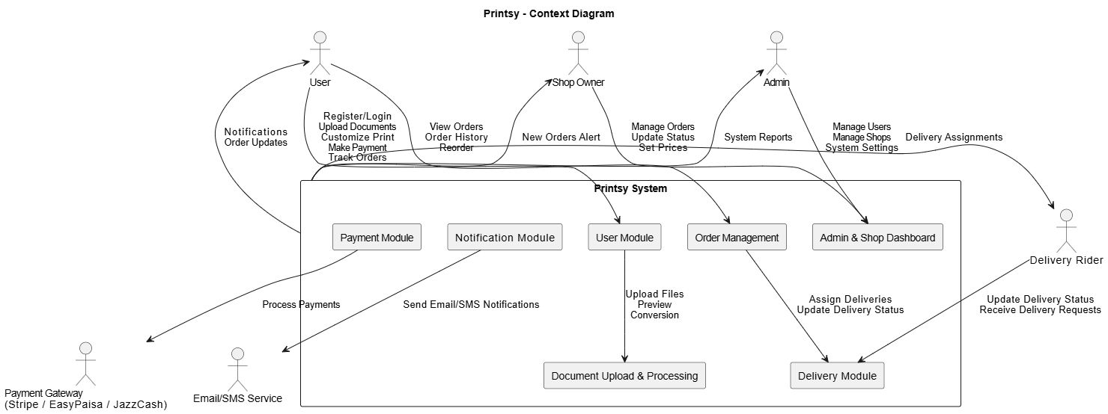

Figure 1: Context diagram of the Printsy.

Example: User Classes and Characteristics

Table 1 Shows user classes and characteristic for Printsy
User Class | Description
User (Customer / Student / General Public) | A User is any individual who wants to upload documents for printing, customize print preferences, make payments, and receive printed materials. Users may include students, office workers, freelancers, or general customers. They interact with Printsy through the website or mobile browser. They will frequently upload common file types (PDF, Word, PPT) and may reorder previous print jobs. Some users may be non-technical, so the system must be simple and intuitive. Users mainly place orders through laptops and mobile devices.
Shop Owner | The Shop Owner operates a printing shop registered on Printsy. They receive new orders, update order status (printing, ready, completed), set printing prices, and handle customer files. Shop owners may have limited technical skills, so the dashboard must be easy to operate. Most Shop Owners will need initial guidance in using the portal to manage orders and adjust pricing.
Admin | The Admin is responsible for managing the entire Printsy platform. This includes managing user accounts, shop registrations, system settings, and generating system reports. Admins ensure the platform runs smoothly and securely. They require advanced system access privileges and technical understanding of the platform.
Delivery Rider | The Delivery Rider receives delivery requests when a print order is marked ready. They pick up printed materials from the shop and deliver them to the user. Their primary interaction is through receiving delivery assignments, updating delivery status, and confirming successful delivery. Riders require a straightforward interface optimized for mobile use.
Payment Gateway (External System) | External payment services (e.g., Stripe, EasyPaisa, JazzCash) used to process digital payments. These gateways interact with Printsy only via secure API calls. They are not human users but act as automated transaction processors.
Email/SMS Notification Service (External System) | A third-party service responsible for sending email or SMS alerts such as order confirmations, status changes, and delivery updates. This service does not require training but must communicate reliably with Printsy’s notification module.

Example: Use case Diagram

Following use case diagram is of an Printsy in which all the use case diagram relationships are presented. In further in Table 2 to the detail of use case diagram sytax is provided.

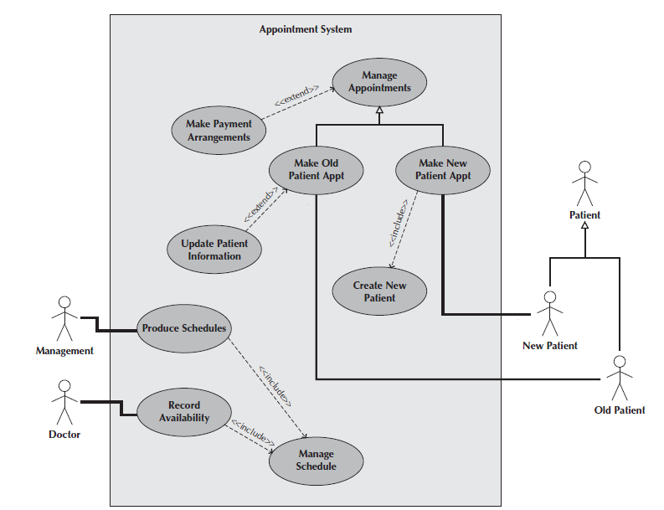

Figure 2: Use Case Diagram of an Appointment System

Syntax for Use case Diagram

Table 2 Syntax for Use case Diagram
An actor:  ■ Is a person or system that derives benefit from and is external to the subject.  ■ Is depicted as either a stick figure (default) or, if a nonhuman actor is involved, a  rectangle with <<actor>> in it (alternative).  ■ Is labeled with its role.  ■ Can be associated with other actors using a specialization/superclass association,  denoted by an arrow with a hollow arrowhead.  ■ Is placed outside the subject boundary. | 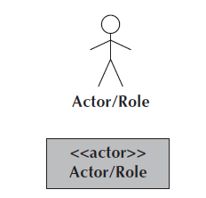
A use case:  ■ Represents a major piece of system functionality.  ■ Can extend another use case.  ■ Can include another use case.  ■ Is placed inside the system boundary.  ■ Is labeled with a descriptive verb–noun phrase. | 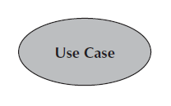
subject boundary:  ■ Includes the name of the subject inside or on top.  ■ Represents the scope of the subject, e.g., a system or an individual  business process. | 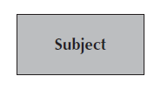
An association relationship:  ■ Links an actor with the use case(s) with which it interacts. | 
An include relationship:  ■ Represents the inclusion of the functionality of one use case within another.  ■ Has an arrow drawn from the base use case to the used use case. | 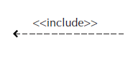
An extend relationship:  ■ Represents the extension of the use case to include optional behavior.  ■ Has an arrow drawn from the extension use case to the base use case. | 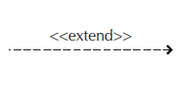
A generalization relationship:  ■ Represents a specialized use case to a more generalized one.  ■ Has an arrow drawn from the specialized use case to the base use case. | 

Detail Use Case Example
Table 3 below indicates a comprehensive use case template filled in with an example drawn from the Cafeteria ordering system (COS).

Table 3 Show the detail use case template and example
USE CASE 1 – User Registration

Use Case ID: | UC-1
Use Case Name: | User Registration
Actors: | Primary Actor: Customer
Description: | Customer registers by providing personal details to access printing services.
Trigger: | Customer clicks “User registration”.
Preconditions: | PRE-1 Customer is not already registered.
Postconditions: | Postconditions:  POST-1. Customer account is successfully created.  POST-2. Customer is redirected to the login page or automatically logged in.
Normal Flow: | - Customer enters names, email, password, and phone number.  - System validates input and checks email uniqueness.  - System creates customer account.  - System redirects customer to login page or starts session.
Alternative Flows: | AF-1: Email Already Registered  - System shows “Email already registered.”  - Customer logs in or enters a different email.  AF-2: Weak Password  - System displays password requirement message.  - Customer re-enters password
Exceptions: | - Missing/invalid input data  - System or database error
Business Rules | Email must be unique  - Password must meet security criteria  - All required fields are mandatory.
Assumptions: | Customers have a valid email.  System services are available.

USE CASE 2 – User Login

Use Case ID: | UC-2
Use Case Name: | User Login
Actors: | Primary Actor: Customer  Secondary Actor: Authentication Service
Description: | Customer logs into Printsy using email and password to access printing services.
Trigger: | Customer clicks “Login”
Preconditions: | PRE-1. Customer must already be registered.
Postconditions: | POST-1. Customer session started successfully.
Normal Flow: | - Customer enters email and password. (see 2.0.E1)  - System validates login credentials.  - System grants access to dashboard.
Alternative Flows: | 2.1 Forgot Password  - Customer clicks “Forgot Password.”  - System sends reset link.  - Customer resets password → return to step 1.
Exceptions: | 2.0.E1 Incorrect Credentials  - System displays “Invalid email or password”.
Business Rules | BR-1 Password must have at least 8 characters.  BR-2 Maximum 3 failed login attempts allowed.
Assumptions: | Assume users have remembered the registered email.

USE CASE 3 – Upload Document

Use Case ID: | UC-3
Use Case Name: | Upload Document
Actors: | Primary Actor: Customer  Secondary Actor: File Processing Module
Description: | Customer uploads a document for printing.
Trigger: | Customer clicks “Upload File.”
Preconditions: | PRE-1. Customer logged in.
Postconditions: | POST-File uploaded successfully.  POST-2. Preview generated
Normal Flow: | - Customer selects a document file.  - System checks file type and size.  - System uploads file.  - System generates file preview.
Alternative Flows: | 3.1 Upload Multiple Files  - Customer selects multiple files.  - System validates all files.  - Return to step 4.
Exceptions: | 3.0. E1Unsupported File Type  3.0. E2 File Size Exceeds Limit
Business Rules | BR-1 PDF/JPG/PNG only.
Assumptions: | Assume stable internet connection.

USE CASE 4 – Place Print Order

Use Case ID: | UC-4
Use Case Name: | Place print order
Actors: | Primary Actor: Customer  Secondary Actor: Print Processing System
Description: | Customer place a print order by uploading documents and selecting print options.
Trigger: | Customer clicks “Place Order”.
Preconditions: | PRE-1 Customer is logged in.  PRE-2 Document uploaded.
Postconditions: | POST-1 Order created with unique Order ID.  POST-2 Order sent to print shop.
Normal Flow: | - Customer selects uploaded documents.  - Customer selects print settings.  - System calculates price.  - Customer confirms order.  - Order is created.
Alternative Flows: | Modify Print Settings  - Customer changes print options.  - System recalculates price.  - Return to step 4
Exceptions: | E1 Missing required settings → show error.
Business Rules | BR-1 Supported formats only.

USE CASE 5 – Make Payment
Use Case ID: | UC-5
Use Case Name: | Make Payment
Actors: | Primary Actor: Customer  Secondary Actor: Payment Gateway
Description: | Customer pays for printing order using available payment methods.
Trigger: | Customer selects “Proceed to Payment.”
Preconditions: | PRE-1. Order placed.
Postconditions: | POST-1. Payment processed.  POST-2. Receipt generated.
Normal Flow: | - Customer selects payment method. (see 6.0.E1)  - System sends payment requests to gateway.  - Gateway processes payment.  - System displays “Payment Successful.”
Alternative Flows: | 5.1 Change Payment Method  - Payment fails.  - Customer selects another method.
Exceptions: | BR-1 Payment failed.
Business Rules | BR-1 Payment mandatory before confirmation.

USE CASE 6 – Track Print Order

Use Case ID: | UC-6
Use Case Name: | Track Print Order
Actors: | Primary Actor: Customer  Secondary Actor: Print Processing System
Description: | Customer views the current status of a print order
Trigger: | Customer clicks “Track Order.”
Preconditions: | PRE-2. At least one order exists.
Postconditions: | POST-1. Order status displayed
Normal Flow: | - Customer selects an existing order.  - System fetches order details.  - System displays:  - In Queue  - Printing  - Completed  - Ready for Pickup  - Cancelled
Alternative Flows: | 6.1 Refresh Status  Customer refreshes page to get latest status.
Exceptions: | E1. Order Not Found  System displays “Order does not exist.”
Business Rules | BR-1 Status must be updated in real time
Assumptions: | Assume printing system updates status

USE CASE 7 –Cancel Order

Use Case ID: | UC-7
Use Case Name: | Cancel order
Actors: | Primary Actor: Customer
Description: | Customer cancels order before printing starts.
Trigger: | Customer clicks “Cancel Order”
Preconditions: | PRE-1. Order not printed.
Postconditions: | POST-1 Order cancelled.
Normal Flow: | - Customer requests cancellation.  - System verifies order stage.  - Order cancelled.
Alternative Flows: | 7.1 Cancel Before Payment  Order removed without refund.
Business Rules | BR-1 Cannot cancel after printing.

USE CASE 8 – View Order History

Use Case ID: | UC-8
Use Case Name: | View Order History
Actors: | Primary Actor: Customer
Description: | Customer views previous orders.
Trigger: | Customer clicks “View Order History”
Preconditions: | PRE-1. Customer logged in.
Postconditions: | POST-1 Order list displayed.
Normal Flow: | - System fetches past orders.  - Displays order details.
Alternative Flows: | 8.1 Reorder  Customer selects old order and reorders.
Business Rules | BR-1 Cannot cancel after printing.

SHOP OWNER USE CASES
USE CASE 9– Shop Owner Registration
Use Case ID: | UC-9
Use Case Name: | Shop owner Registration
Actors: | Primary Actor: Shop owner  Secondary Actor: Authentication Service
Description: | Shop Owner registers on Printsy by providing shop and personal details to access shop dashboard.
Trigger: | Shope owner clicks “Registration”
Preconditions: | PRE-1. Shop Owner is not already registered.
Postconditions: | POST-1. Shop Owner account created.  POST-2. Shop profile saved
Normal Flow: | Shop Owner selects “Register as Shop Owner”.  System displays registration forms.  Shop Owner enters:  - Owner name  - Email  - Password  - Shop name  - Shop address  - Contact number  - System validates input.  - System creates shop owner’s account.  - System notifies admin for approval (optional).
Alternative Flows: | 1.1 Invalid Data  - System shows validation error → return to step 3.
Exceptions: | E1 Email Already Exists  - System displays error message.
Business Rules | BR-1 Shop owner email must be unique.  BR-2 Password must meet security policy.
Assumptions: | Assume shop owner provides valid business details.

USE CASE 10– Shop Owner login

Use Case ID: | UC-10
Use Case Name: | Shop owner login
Actors: | Primary Actor: Shop owner  Secondary Actor: Authentication Service
Description: | Shop Owner logs into Printsy to manage print orders and pricing.
Trigger: | Shop owner clicks “Shop Owner login”
Preconditions: | PRE-1. Shop Owner account exists.  PRE-2. Shop account is approved by admin.
Postconditions: | POST-1. Shop Owner session started.  POST-2. Shop dashboard displayed.
Normal Flow: | - Shop Owner enters email and password.  - System validates credentials.  - System verifies shop status.  - System grants access to shop dashboard.
Alternative Flows: | Forget Password  System sends reset link → return to step 1.
Exceptions: | E1 Invalid Credentials  - System displays “Invalid email or password”.
Business Rules | - BR-1 Maximum 3 failed login attempts allowed.  - BR-2 Session timeout after 15 minutes inactivity.
Assumptions: | Assume shop owner remembers registered credentials.

USE CASE 11 – View Orders
Use Case ID: | UC-11
Use Case Name: | View order
Actors: | Primary Actor: Shop Owner  Secondary Actor: order management system
Description: | Shop Owner logs into Printsy and views all incoming print orders for their shop.
Trigger: | Shope owner clicks “view orders”
Preconditions: | PRE-1. Shop Owner must be logged in.  PRE-2. Shop must be active.
Postconditions: | POST-1. List of shop orders displayed.
Normal Flow: | - Shop Owner selects “Orders” from dashboard.  - System fetches shop orders.  - System displays order list.
Alternative Flows: | 9.1 Filter Orders  - Shop Owner applies status/date filter.  - System updates order list.
Exceptions: | 9.0.E1 No Orders Found  - System displays “No orders available”.
Business Rules | BR-Shop Owner can view only their own shop’s orders.
Assumptions: | Assume shop has received orders.

USE CASE 12 – Accept / Reject Order
Use Case ID: | UC-12
Use Case Name: | Accept / Reject Order
Actors: | Primary Actor: Shop Owner
Description: | The Shop Owner accepts or rejects incoming customer orders.
Trigger: | The Shop Owner selects “Accept / Reject Order.”
Preconditions: | PRE-1. The Shop Owner is logged in.  PRE-2. The order is in a pending state.
Postconditions: | POST-1. The order status is updated to Accepted or Rejected.
Normal Flow: | - The Shop Owner selects an order.  - The Shop Owner chooses to accept or reject the order.  - The system updates the order status.
Alternative Flows: | 4.1 Reject Order  - The Shop Owner provides a rejection reason
Exceptions:
Business Rules | BR-1 Only pending orders can be accepted or rejected.
Assumptions: | The Shop Owner reviews order details before taking action.

USE CASE 13– Update Order Status
Use Case ID: | UC-13
Use Case Name: | Update Order Status
Actors: | Primary Actor: shop Owner  Secondary Actor: Order management system
Description: | Shop Owner updates the status of a print order.
Trigger: | Shope owner clicks “Update order status”
Preconditions: | PRE-1. Shop Owner logged in.  PRE-2. Order exists.
Postconditions: | POST-1. Order status updated.
Normal Flow: | 1 Shop Owner selects an order.  - Shop Owner selects new status.  - System saves updated status.  .
Alternative Flows: | 10.1 Delay Order  - Shop Owner marks order as “Delayed”
Exceptions: | 10.0.E1 Invalid Status  - System displays error message.
Business Rules | BR-1 Status must follow defined workflow sequence.
Assumptions: | Assume printing process is operational

USE CASE 14– Set Print Prices
Use Case ID: | UC-14
Use Case Name: | Set Print Prices
Actors: | Primary Actor: Shop Owner  Secondary Actor: Pricing Module
Description: | Shop Owner sets or updates printing prices.
Trigger: | Shope owner clicks “Price setting”
Preconditions: | PRE-1. Shop Owner logged in.
Postconditions: | POST-1. price updated successfully.
Normal Flow: | Shop Owner enters price per page.  System validates price.  System saves pricing data.
Alternative Flows: | 11. Update Existing Prices  - Shop Owner edits existing prices.
Exceptions: | 11.0.E1 Invalid Price  - System displays validation error.
Business Rules | BR-1 Price must be greater than zero.
Assumptions: | Assume shop owner controls pricing.

USE CASE 15– View Earnings / Reports
Use Case ID: | UC-15
Use Case Name: | View Earnings / Reports
Actors: | Primary Actor: Shope Owner  Secondary Actor: Pricing Module
Description: | The Shop Owner views earnings and sales reports for the shop.
Trigger: | The Shop Owner selects “View Earnings / Reports.”
Preconditions: | PRE-1. The Shop Owner is logged in.
Postconditions: | POST-1. Earnings and reports are displayed.
Normal Flow: | - The Shop Owner opens the reports section.  - The system calculates earnings.  - The system displays reports.
Alternative Flows: | 8.1 Filter Reports  - The Shop Owner selects a date range.  - The system displays filtered reports.
Exceptions:
Business Rules | BR-1 Reports are generated only for the Shop Owner’s shop.
Assumptions: | Payment and order data are available.

ADMIN USE CASES
USE CASE 16– Admin Login
Use Case ID: | UC-16
Use Case Name: | Admin Login
Actors: | Primary Actor: Admin  Secondary Actor: Authentication service
Description: | Admin logs into Printsy to manage system operations.
Trigger: | Admin clicks “Login”.
Preconditions: | PRE-1. Admin account exists.
Postconditions: | POST-1. Admin session started successfully.
Normal Flow: | Admin enters email and password.  System validates credentials.  Admin dashboard displayed.
Alternative Flows: | 12.1 Forgot Password  - Admin clicks “Forgot Password”.  - System sends reset link.  - Admin resets password → return to step 1.
Exceptions: | 12.0.E1 Invalid Credentials  - System displays error messages.
Business Rules | BR-1 Strong password policy applies.
Assumptions: | Assume admin has access to registered email.

USE CASE 17– Manage Shop Owners
Use Case ID: | UC-17
Use Case Name: | Manage Shop Owners
Actors: | Primary Actor: Admin  Secondary Actor: Management System
Description: | Admin approves, updates, or disables shop owner accounts.
Trigger: | Admin selects “Manage Shops”.
Preconditions: | PRE-1. Admin logged in.
Postconditions: | POST-1. Shop owner record updated.
Normal Flow: | - Admin views shop owner list.  - Admin approves or rejects new shop registration.  - Admin updates shop status.  - System saves changes.
Alternative Flows: | 2.1 Disable Shop  - Admin disables shop account.  .
Exceptions:
Business Rules | BR-1 Only admin can approve shop owners.

USE CASE 18– Generate Reports
Use Case ID: | UC-18
Use Case Name: | Generate Reports
Actors: | Primary Actor: Admin  Secondary Actor: Reporting Module
Description: | Admin generates system sales and usage reports.
Trigger: | Admin clicks “Generate Reports”.
Preconditions: | PRE-1. Admin logged in.  PRE-2. Data exists.
Postconditions: | POST-1. Report generated.
Normal Flow: | Admin selects report type.  System processes data.  System display report.
Alternative Flows: | 14.1 Change Time Period  - Admin selects weekly/monthly report.
Exceptions: | 5.0.E1 No Data Available  - System displays messages.
Business Rules | BR-1 Reports are read-only.
Assumptions: | Assume system data is up to date.

Use Case Diagram
All System:
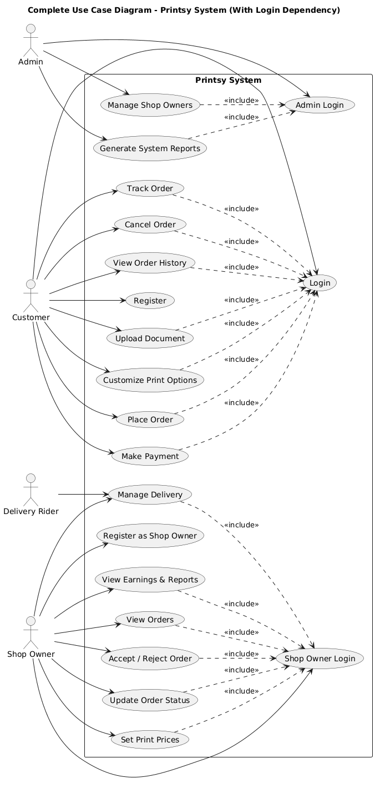
Admin Use case Diagram:
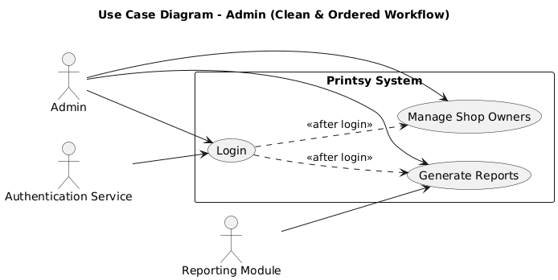
User Use case Diagram:
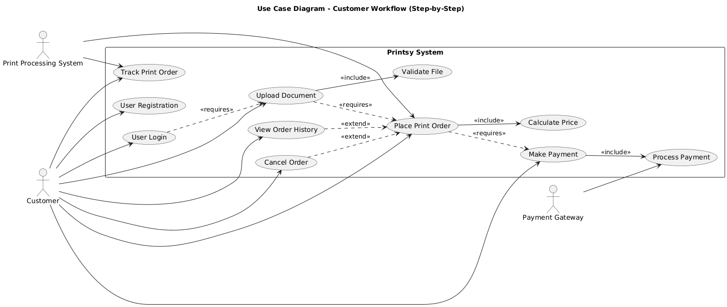

Shop use case Diagram:
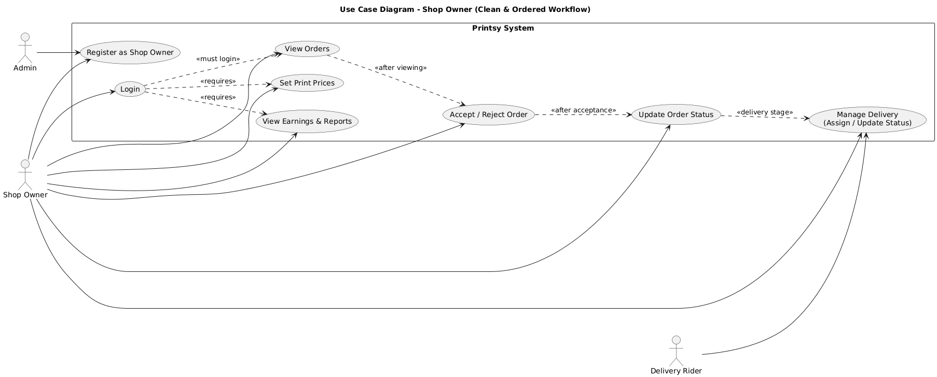

All use cases diagrams:

Use Case 1:
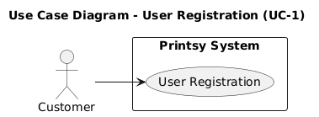

Use Case 2:
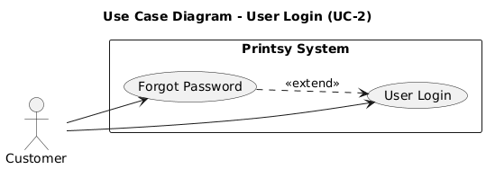
Use Case 3:
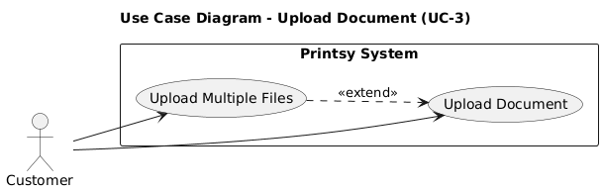

Use Case 4:
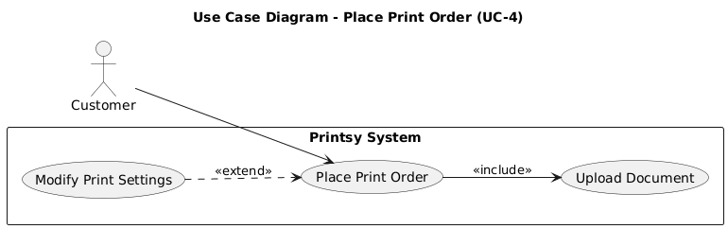

Use Case 5:
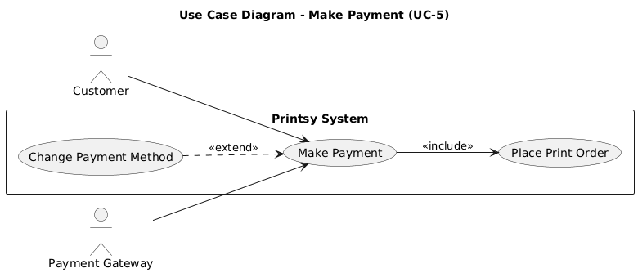
Use Case 6:

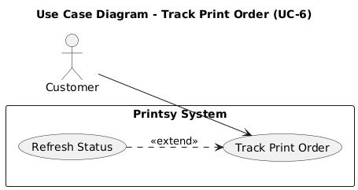

Use Case 7:

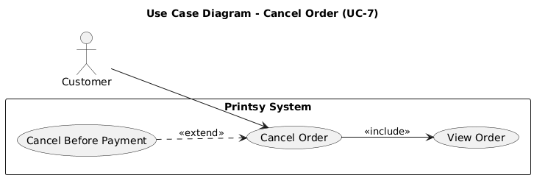
Use Case 8:
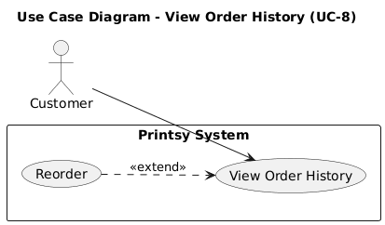

Use Case 9:
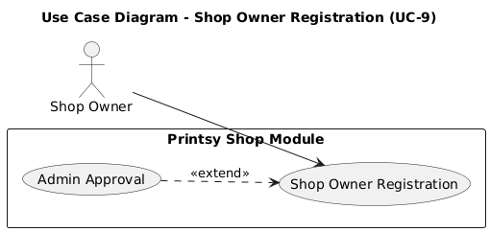

Use Case 10:
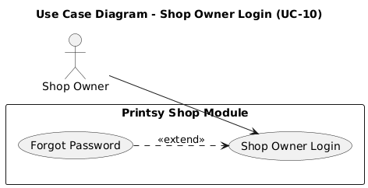
Use Case 11:

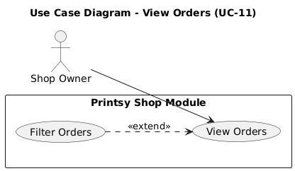

Use Case 12:

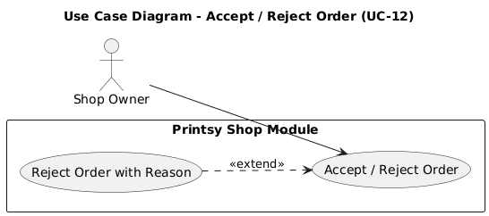
Use Case 13:
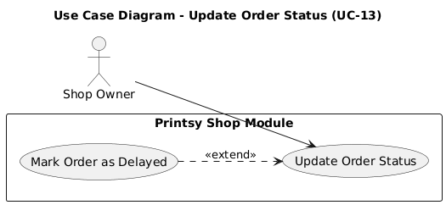

Use Case 14:
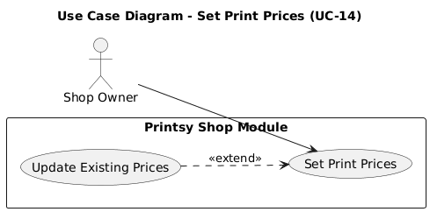

Use Case 15:

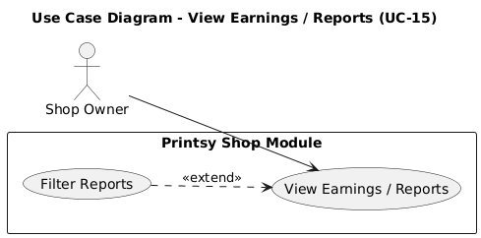

Use Case 16:
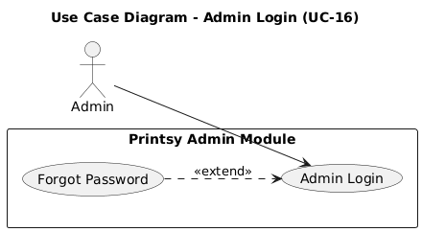

Use Case 17:

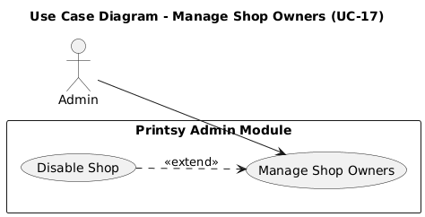

Use Case 18:

